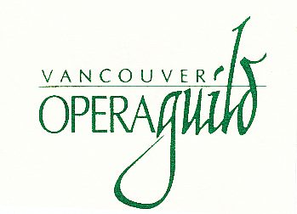

**Vancouver Opera Guild**

# 2025 Career Development Grant - Singers

**($7,000)**

**Check list for applicants - these materials must be included with your application**:

1. **Proof of age and citizenship** – one of the following: birth certificate, passport, driver’s licence

2. **Detailed description of your project**:

**•** scope

**•** time to complete

**•** results sought

**•** purpose to which the grant will be applied

**•** a brief statement of other resources available for the project

3. **Budget** – your total cost should include where applicable:

**•** registration costs

**•** all travel expenses

**•** accommodation

**•** meals

**•** cost of coaching and/or accompanist (if applicable)

**•** travel insurance (if applicable)

4. **Three videos of contrasting opera arias, in at least two languages:**

* with piano accompaniment only, to a maximum of 15 minutes of music
* your submission must be of professional quality
* it must be an unedited recent performance
* all applicants must send links where his/her videos can be viewed by the judges, clearly labelled with aria, opera, composer and performer

**5.** **Current letters of reference (2)** – from two established professionals in the field – voice teachers, coaches, specialists in the field of opera, etc.

**6. Curriculum vitae:**

**•** must include a recent photo/headshot – minimum size 6” X 8” (preferred size: 8-1/2” X 11”)